Programmable Interval Timer

- What is it?
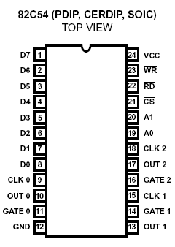
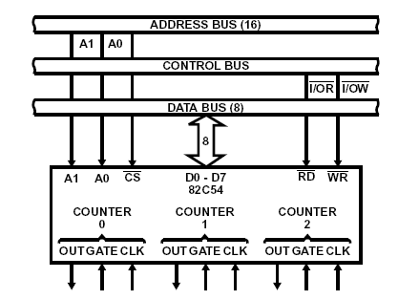

- Yet another chip connected to the processor through the BUSes.
- Accessed through I/O ports. (IN/OUT instructions)
- A chip to help the processor
- Timer / Counter

- How do you deal with time (delay) in your program?
    - Delay Loops
    - System Functions
    - …? PIT?

      - Generation of accurate time delays under software control
      - Minimal software overhead
      - Variable length delays can easily be accommodated

- PIT is simply three identical counters. But what is a counter?
      - What is EE2006? Remember?
      - Count clock signals ---- Input CLK
      - Numerical States ---- Q7~Q0
      - Output Signal ----- To indicate a special state
      - The counters in PIT are under software control --- The Modes
      - Configurable Output Signal
      - Initial Count Configurable
      - Flexible Monitoring
- How to program the PIT?
- Four Ports ( One for each counter, And One for Control)
- Write to configure the counters
- Read to monitor the counters
- How to Configure the PIT? ( Write )
- What to configure?
  - Initial Counts -- Each counter has a dedicated port.
  - Control Word -- Configuration for all the counters
- Sequence of Operation
  - For each Counter, the Control Word must be written before the initial count is written.
  - The initial count must follow the count format specified in the Control Word (least significant byte only, most significant byte only, or least significant byte and then most significant byte).
- Definition of the Control Word
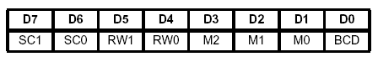
- Each Bit Described

SC - Select Counter
SC1 | SC0
0 | 0 | Select Counter 0
0 | 1 | Select Counter 1
1 | 0 | Select Counter 2
1 | 1 | Read-Back Command

RW - Read/Write
RW1 | RW0
0 | 0 | Counter Latch Command (See Read Operations)
0 | 1 | Read/Write least significant byte only.
1 | 0 | Read/Write most significant byte only.
1 | 1 | Read/Write least significant byte first, then most significant byte.

M – Mode
M2 | M1 | M0
0 | 0 | 0 | Mode 0
0 | 0 | 1 | Mode 1
X | 1 | 0 | Mode 2
X | 1 | 1 | Mode 3
1 | 0 | 0 | Mode 4
1 | 0 | 1 | Mode5

BCD - Binary Coded Decimal
0 | Binary Counter 16-bit
1 | Binary Coded Decimal (BCD) Counter (4 Decades)
- How to monitor the counters? ( Read )
- What to monitor?
  - The current count
  - The current configuration
- A big problem: the Counters are always counting!
- Latch it and Read it
  - First Write to the Control Word to latch certain counter
  - Then read it through the port
  - If you latch more than once, all ONLY the FIRST is latched.
- How many ways to read?
- Three ways:
  - Direct Read
  - Using “Counter Latch Command”
  - Using “Read Back Command”
- Direct Read is not safe.
- Counter Latch Command
  - Write the following word to Control Word Port:
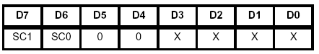
  - Read each counter port to get the latched count.
- Read Back Command
  - Write the following word to Control Word Port:
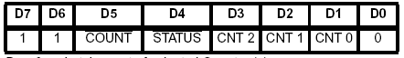
  - /COUNT and /STATUS indicates what to latch
  - CNT2~CNT0 indicates which counter(s) to latch
  - Equivalent to several counter latch commands, one for each counter latched.
  - You can latch Status and Count together.
    - In this case, you have to read the counter port twice
    - The first byte you get will be the STATUS
    - The second byte you get will be the COUNT.
  - The STATUS is defined as below:
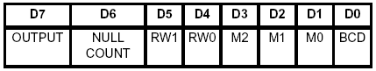
- What are the modes? (Read the Datasheet)
- Altogether SIX modes
- Defines how the OUTPUT signal is generated.
- GATE is an input signal usually used as gate or trigger.
- For example: Mode 0 --- Interrupt on Terminal Count
  - First load Control Word and Initial Count
  - CLK input will be counted and the counter decreased.
  - When decreased to zero, OUTPUT signal is asserted.
  - GATE signal will gate the CLK. (Like an AND Gate)
- Designated functions of each counter in PC.
- Counter 0: To generate INT 8. A time interrupt that appears 18.2 times per second. (Mode 3)
- Counter 1: To generate RAM refreshing clock. (Mode 2)
- Counter 2: To generate tones for the speaker. (Mode 3)
- Sample Code
cli
mov al,00110110b ; bit 7,6 = (00) timer counter 0
; bit 5,4 = (11) write LSB then MSB
; bit 3-1 = (011) generate square wave
; bit 0 = (0) binary counter
out 43h,al ; prep PIT, counter 0, square wave&init count
jmp $+2
mov cx,countdown ; default is 0x0000 (65536) (18.2 per sec)
; interrupts when counter decrements to 0
mov al,cl ; send LSB of timer count
out 40h,al
jmp $+2
mov al,ch ; send MSB of timer count
out 40h,al
jmp $+2
sti

